Bronx
Developmental Disabilities Council
C/O Rose F. Kennedy University Center for Excellence in Developmental Disabilities
1225 Morris Park Avenue – Room 2C - 46
Bronx, NY 10461
www.bronxddcouncil.org

Joanne Florio Siegel, President

Edie Weber, Family, Self-Advocate Vice President
Omayra Andino, Provider Vice President
Doris Figueroa, Secretary
Peter Dolan, Treasurer

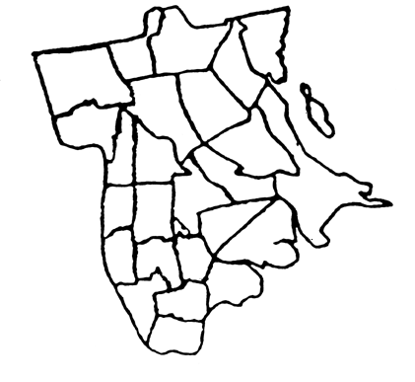
January 19, 2018

Dear Bronx DD Council Members and Friends:

We would like to invite you to attend our Annual Legislative Breakfast scheduled on Friday, March 16, 2018 from 8 AM to 11 AM. Our breakfast will be held at Maestro’s, 1703 Bronxdale Avenue (Between Morris Park and East Tremont Avenues), Bronx, NY.

Once again this event will be co-hosted by Bronx Borough President Ruben Diaz, Jr. We are also in the process of securing our legislative hosts for this year’s breakfast, and we have invited leaders on a Federal level to address concerns about the future of Medicaid. Representatives from OPWDD will provide an update on the latest status of the Front Door Initiative and Medicaid managed care. We have also invited officials from the New York City Department of Health and Mental Hygiene to comment on issues faced by people with disabilities and their families living in New York City.

The legislative breakfast will focus not only on the above issues but other pertinent, budget and development issues such as growing wait lists for residential and housing services, a living wage Direct Support Professional, the impact of rate rationalization, clinical issues, and underfunding of Early Intervention and Preschool Programs. In this most difficult time, we will join forces with the other borough-wide Councils as we look to restore, sustain and expand services for the individuals with disabilities in the Bronx and throughout the City of New York.

The admission to this event is $30.00, which includes a full sit down breakfast. Please RSVP by Friday, March 10, 2018 by completing and mailing the bottom portion of this invitation, along with your check.

Please show your support for services for people with developmental disabilities in the Bronx by attending this important event!

Sincerely,
Joanne Florio Siegel
President, Bronx DD Council

BRONX LEGISLATIVE BREAKFAST RSVP
Please Print Legibly

______________________ ___________________________
NAME ADDRESS
_______________________________
AGENCY, AFFILIATION / TITLE

________________________________ _______________________________
TELEPHONE ANY SEATING PREFERENCE?

MAIL TO: BRONX DD COUNCIL c/o Rose F Kennedy Center UCEDD, 1225 Morris Park Avenue, Bronx, New York 10461 Attention: Phyllis Angelico Email address: pangelic@montefiore.org

PLEASE ENCLOSE A CHECK FOR $30. PAYABLE TO BRONX DD COUNCIL

